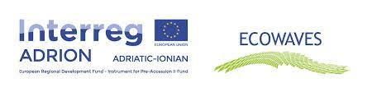

PROJECT
ECOWAVES
INTERREG IPA II CROSS-BORDER COOPERATION
ADRION ( 2014 – 2020)

Local Capacity Training, “Port reception facilities for the delivery of waste from ships”
Agenda , ( Work package T2, deliverable T.2.1.1)

March 9th, 2022
10:00 AM
Hotel Regina Garden , Vlora

10: 00 – 10: 30 | - Registration of the Participants
10:30-11:30 | - International regulatory framework on Port Reception Facilities (IMO)
11:30-14:30 | - Consolidated guidance for port reception facility providers and users (MEPC.1/Circ.834/Rev.1)  - Guidelines for ensuring the adequacy of port waste reception facilities (Resolution MEPC.83(44)  - EU regulatory framework on port reception facilities for the delivery of waste from ships (Directive (EU) 2019/883)  - The implementation of a cost recovery system applying the “polluter pays” principle
14:30-15:45 | - Round Table Discussions  - Conclusions
15:45 | - Buffet Lunch

